??? Child Contact Centre

Childrens Guide


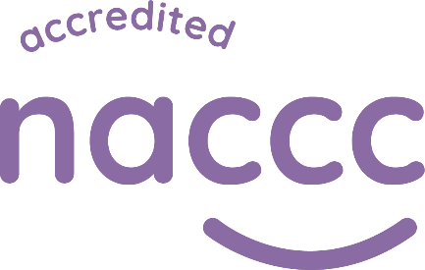
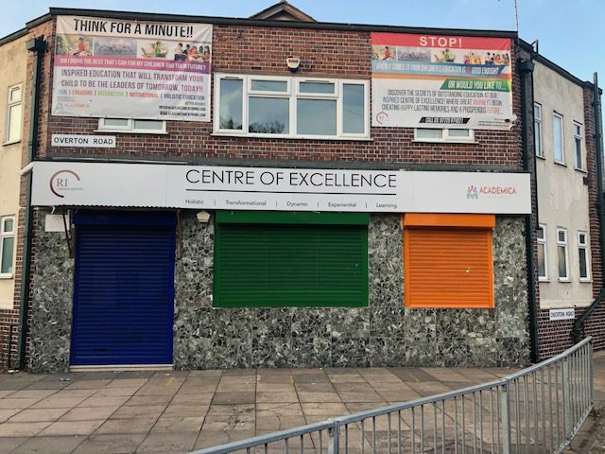
2 Overton Rd, Leicester, LE5 0JA
07725974831
info@raedan-institute.co.uk
For more information visit
https://naccc.org.uk/for-children/






What We Do!
Our contact centre provides a safe place for you to spend time with the people that you care about. We know that using a contact centre can be a big change. Our staff will be available to you to help you to feel safe. If you have any problems or worries let us know and we will do our best to help.

Before you use our service, you will have the chance to come and have a visit. During this time, you will be able to:
- Have a look around.
- Find out how we will work with you – when sessions will be, what the staff will be doing, how long you will use the centre and other things that might be helpful to know.
- Ask any questions – Don’t be afraid to ask. The staff will have heard your question before and will want to help you to find the answers. You might want to know if you can take photos, bring a favourite toy, or wear your best clothes.
- Find out some rules – There are not too many to remember.
- Understand how the service will help you to feel ok.


What will it be like?
We hope that you will enjoy your time with us, and we will do all we can to make sure you are only here for as long as you need our services.  You might meet many members of our team, but we will work hard to make sure that you are able to recognise familiar faces, and our staff always have a name badge to help you to find them.  You may spend time in a room with other children and families who are spending time together. Our team will also be in the room, and you will be able to see us at all times. We are there for your comfort, but you will have privacy and we will not be listening to all conversations you have with the person you are visiting.  We do not usually write notes about the time you have spent here. That shouldn’t worry you though, if something happened that others needed to know about we would record that.  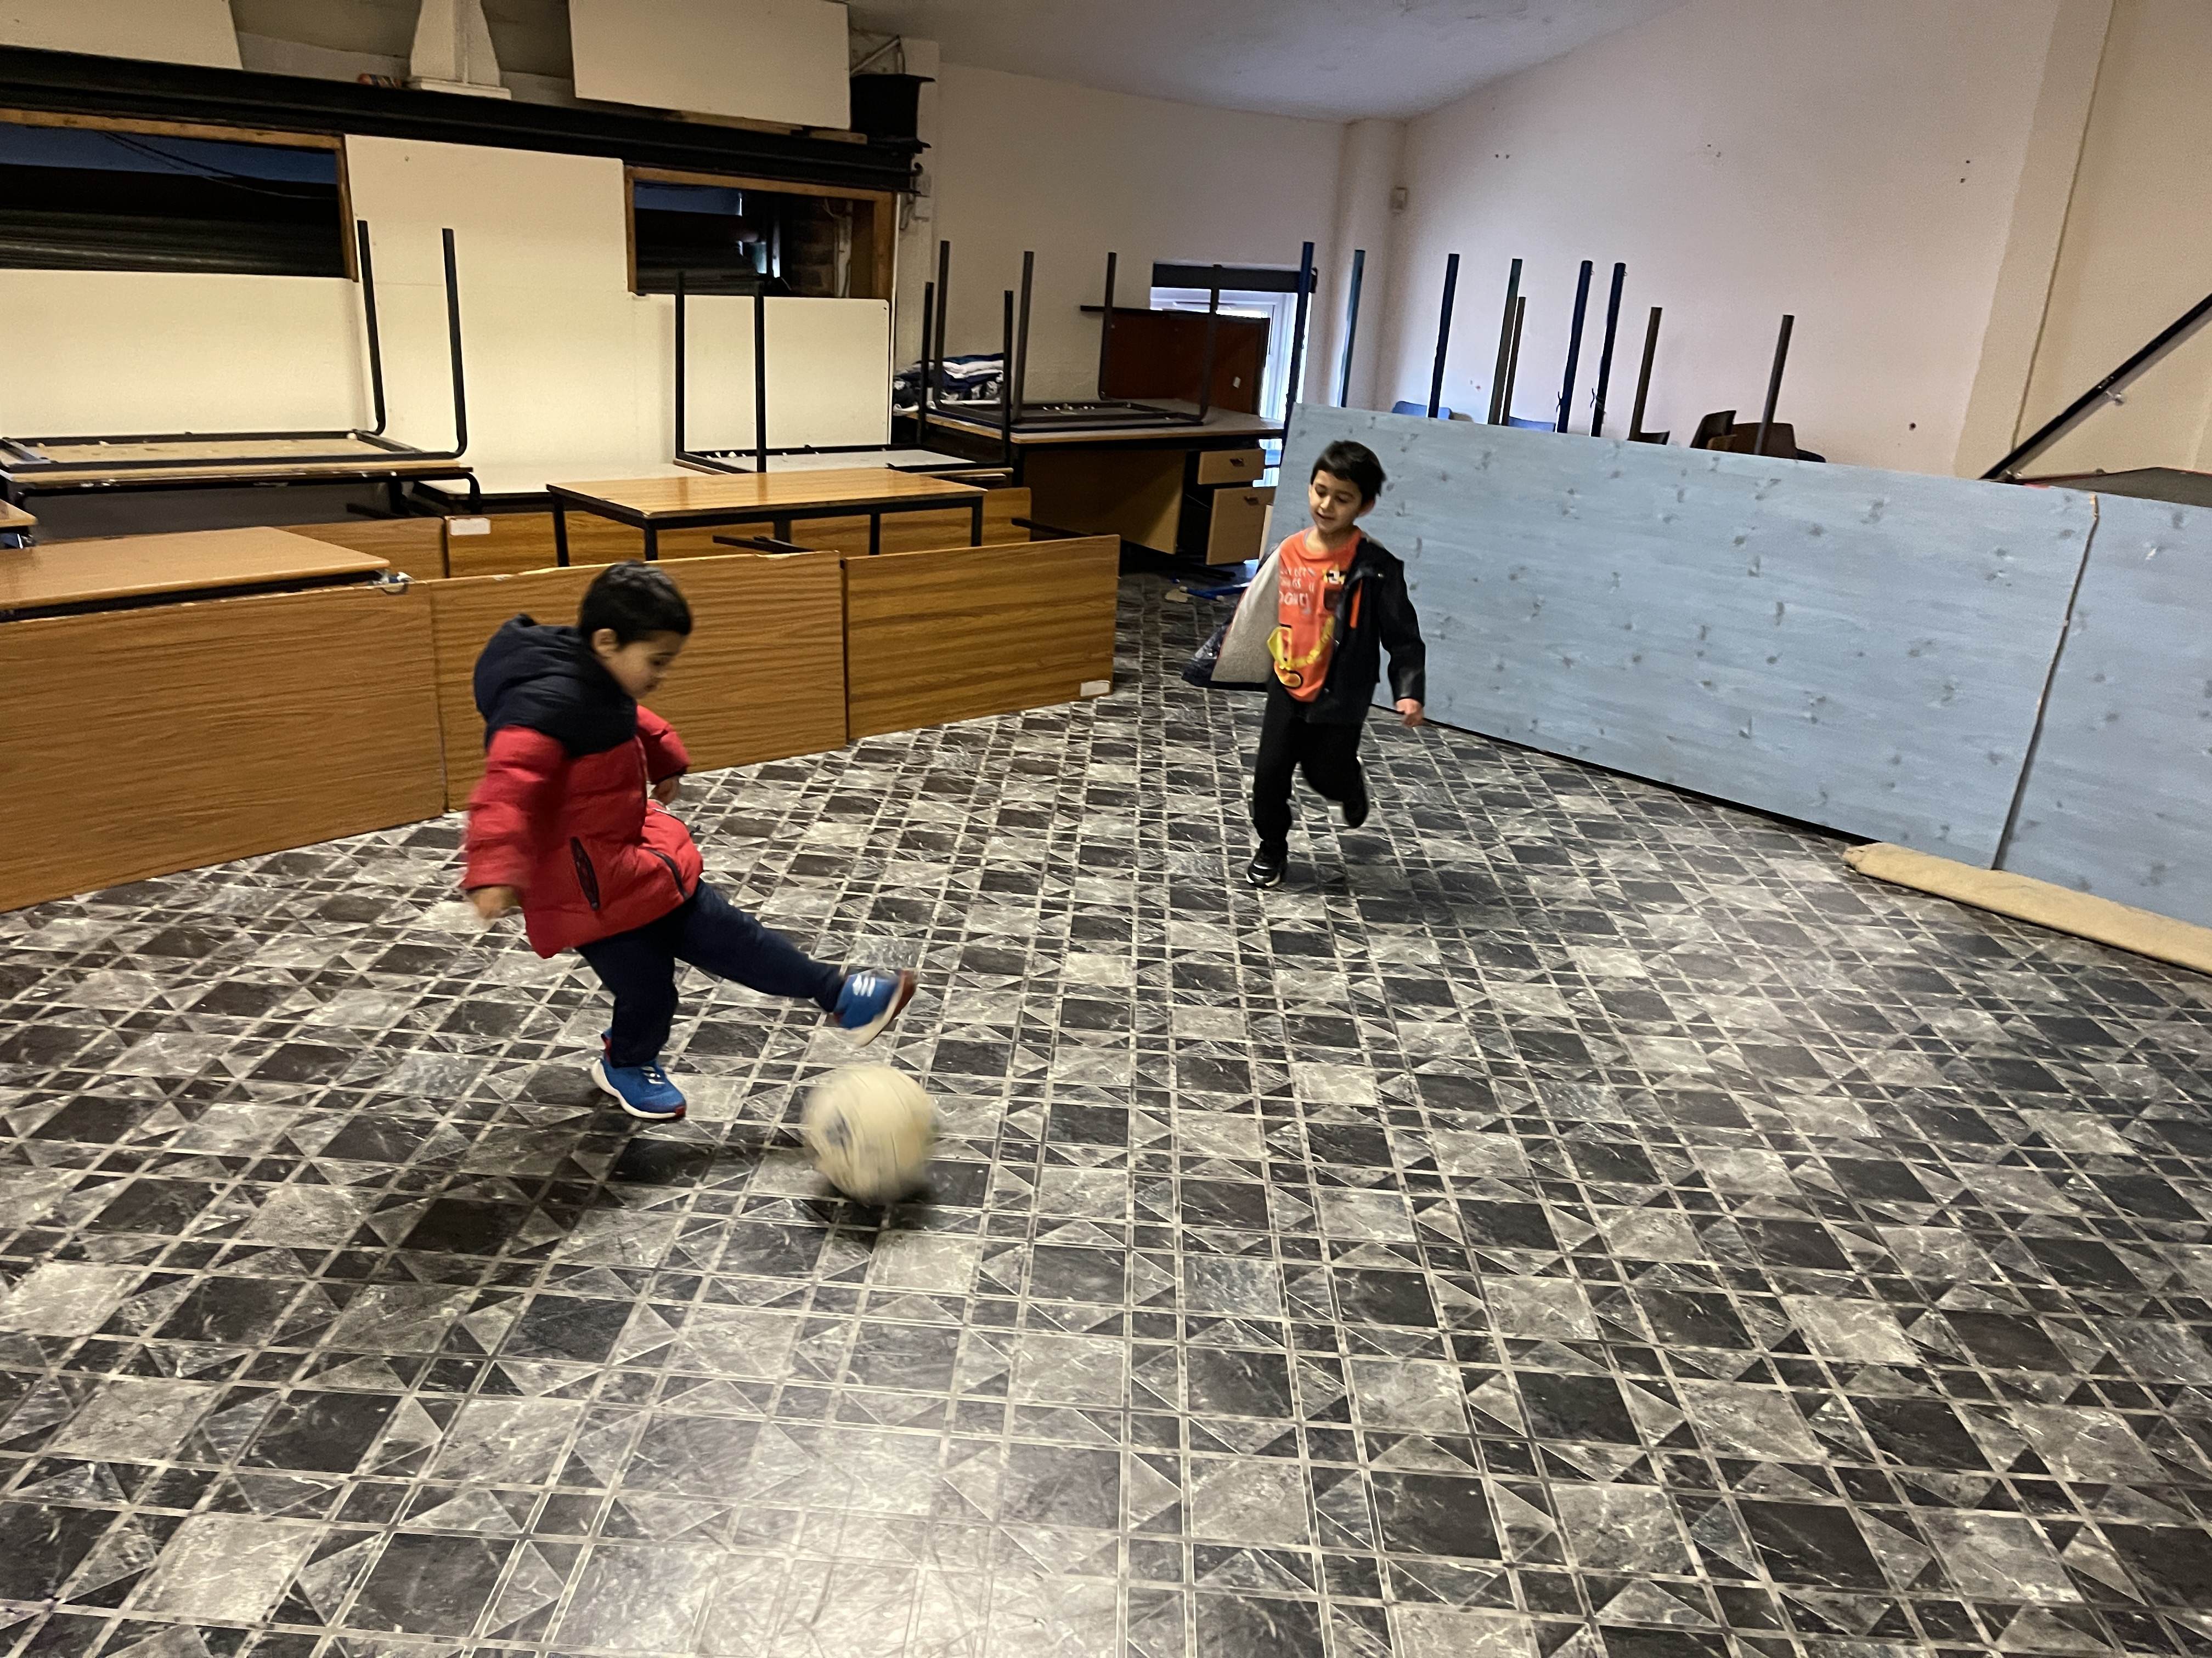  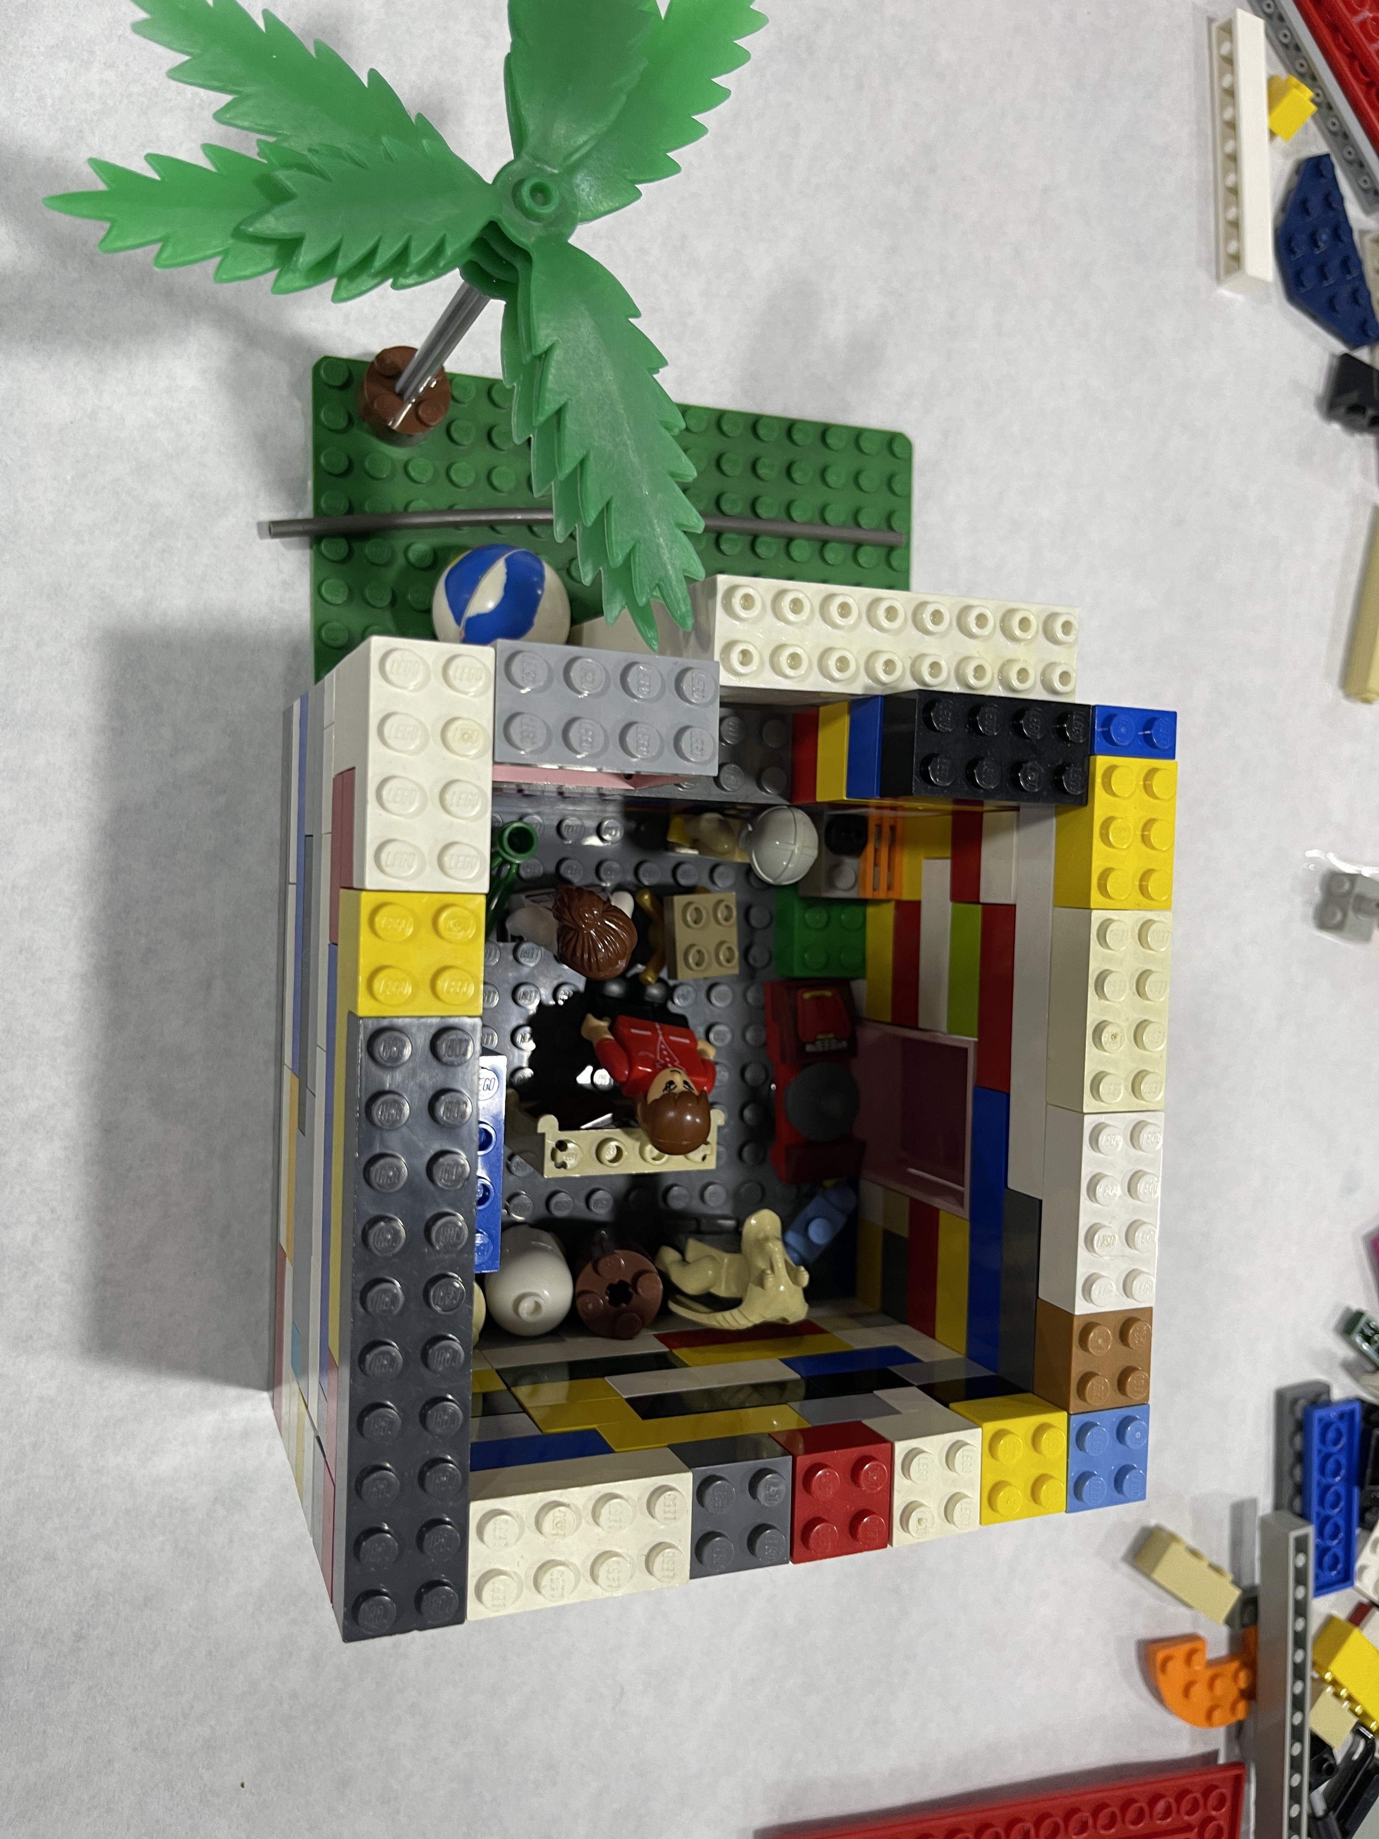 |  | 
 |  |  | 
 |  | 
 |  |  | 
 |  | 
 |  | 
 |  |  | 
 | What If I am not happy?
There have been some big changes in your life, and there might be some more. Its normal to worry about this and to feel uncertain about the future. The NACCC Website has lots of information for you. You can easily find this on google, or by typing the following link into your web browser - https://naccc.org.uk/for-children/


If you are unhappy tell us. We will always do our best to help.

If you have other professionals in your life like a Teacher, Social Worker, Cafcass Staff Member, Youth Worker, or anyone else you trust it is ok to talk to them too. They will be able to help.

Sometimes we make mistakes. If you think we have done something wrong and you don’t want to talk to us about this, we do have a complaint procedure. Our staff can help you to understand how to make complaints.

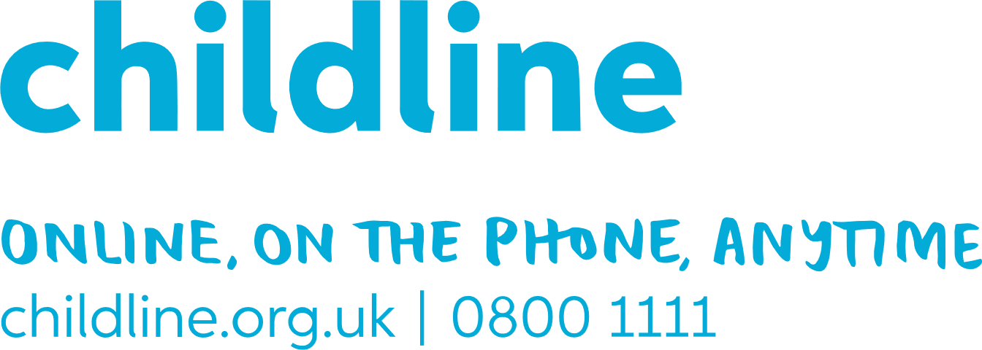
Childline are also available to talk to about anything that worries you. They provide a confidential service and will not tell us what you say to them unless you ask them to. They also have lots of great information on the Childline Website.

